Welcome to Rhondda Valley Runners Beginners Programme!
Thanks for your interest in joining us! We aim to help you enjoy your time running with us and promise that we’ll help you meet your fitness goals.
Who are we?
All helpers and coaches at RVR Beginners are volunteers and are experienced runners who are members of the main Club. Rhondda Calley Runners is a well-established club, affiliated to Welsh Athletics and governed by constitution.
What can I expect?
After a short warmup, you will run with one of three groups depending on your running ability. Routes will vary, and will gradually build up in distance and difficulty over the programme. At the end of each run you will be led in a stretching session which will help you recover and avoid injury.
The beginners’ programme runs for 10 weeks, after which we would expect you to join the main club runs.
How much is it:
The cost for the programme is £15.

Running tips
When running with the group please following the guidelines below, out of courtesy to others and safety for yourself and others.
- be aware of the traffic and obstacles around you: this means not covering your ears – please do not use headphones;
- always take instructions from the group leaders;
- wear appropriate clothing including high visibility if running on a dark night;
- on shorter runs, it is not worth carrying a bottle. Save it for the end of the run!
- cross roads as a group, don’t string out across the road;
- particularly in the dark beware of holes, kerbs, bollards, roots and tarmac lifted by tree roots, and poorly levelled or slippery gratings and chamber covers;
- pavements in the Rhondda can be narrow, especially on Mondays when rubbish bags are put out, take care when the path narrows;
- warn fellow runners of hazards you see;
- be aware of pedestrians particularly when running up behind people: it can be scary when a group of heavy breathing individuals run up behind you! Thank pedestrians who give way;
- leave space between you and the runner in front in case of a change of direction (including that caused by tripping!) or stopping for traffic;
- if you find yourself ahead of the group please ‘loop back’ for the runners behind you: this will ensure the group stays together and will ensure that everyone in the group is getting the best from their run;
- if you decide to turn back early ensure the group leader is informed.

What to wear?
Lightweight running clothing is best, if cold add more thin layers. Running clothes can be purchased reasonably cheaply at shops such as Sports Direct, etc.
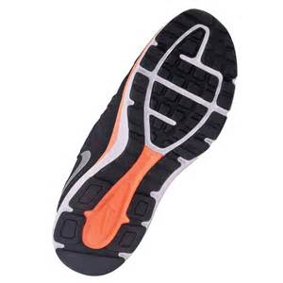
It is important to wear good shoes, which can help you avoid injury. Many shops do a gait analysis which can help you to be fitted with the correct shoes for you, but the important thing is to get shoes which are designed for running, especially as the miles increase. If in doubt, buy a pair of neutral road shoes.
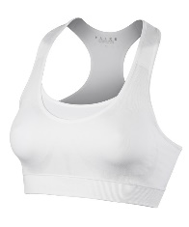
For the ladies, a good sports bra is as essential a piece of kit as a good pair of trainers. A bra should fit snugly without the rib band restricting breathing, and straps need to be wide enough to support the breast without causing ridges on your shoulders.
Stretching
It is important to stretch after each run to promote recovery and flexibility. We will lead stretching exercises after each run, but if you run on your own you might like to consider the following stretches:
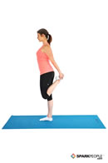  Standing Quad Stretch | 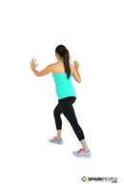  Leaning Single-leg Calf Stretch | 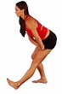  Hamstring Stretch
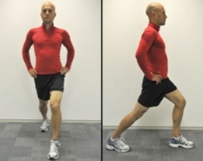  Hip Flexor Stretch | Arm stretch (smile optional!) | Shoulder stretch

Follow us on
Facebook (Rhondda Valley Runners and Rhondda Valley Runners Beginners Page)
Website http://www.rhonddavalleyrunners
Email for Beginners group: rvrbeginners@gmail.com
Application form available here

Committee
Rachel Walters – Chair
Amy Edwards – Secretary
Victoria O’Reilly – Treasurer
Gareth Denton – Fixtures/Media
Angharad Bevan – Welfare Officer
Dave Reed – Training Officer
Dawne Meynell-Western – Social Secretary
Alison Gardiner, Angharad Bevan, Hayley Gittins – Beginners’ Co-ordinators

